**Please watch a pre-recorded lecture**

<https://wisconsin-edu.zoom.us/rec/share/_ftIU98CxJH9D9oCXxp55pNP5gULYdpaJML6nV0K-WVE6b_4ldpAKiakWXZRrxFu.yo37YkFCAMdDYMIp?startTime=1652387444000>

**5.19. Class task and assignment**

Please complete today’s writing assignment with your group members for the Final Project. Due noon. 请所有同学按照期末项目小组的分组，完成下面内容.中午前提交。

(* Below is the grouping information for those who had class conflict this semester这是课程有冲突的同学的分组)

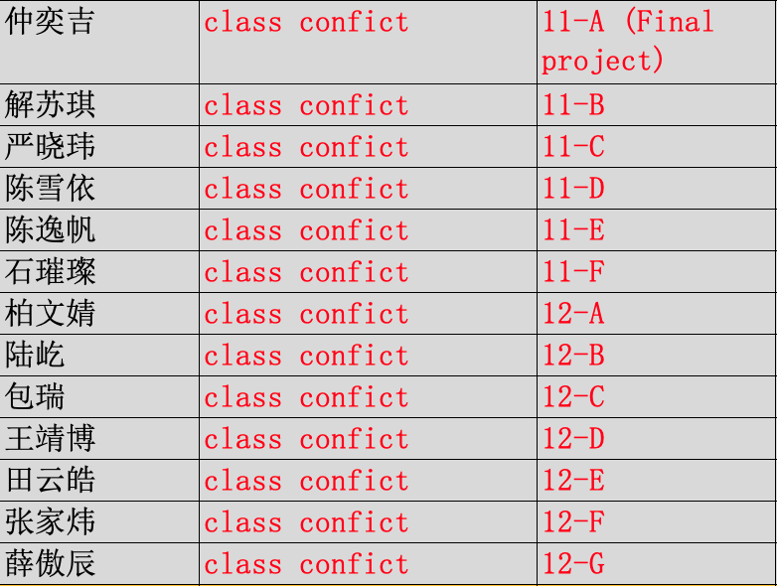

|  |
| --- |
| Your group number _______ (你们小组的号码) |
| Who participated in today’s discussion: （今天参与了讨论的同学名字和他们的字母代号ABCD…） |
| Who is submitting this group form today: Member E  今天负责提交作业的小组代表___________ |
| |  | | --- | | **Final group project**  **Step 4: Your civic duty (Member E)** | | * Propose three action plans to help improve this situation (Finish the table #3) * What is each action plan about? Who will be involved? What will you do? * Who will benefit from these action plans? Will these action plans harm anyone? * How are these action plans going to impact the society and the people? * How will these action plans contribute to the industry in China? * How will these action plans contribute to the world? * Fill out the table below.  |  |  |  |  |  | | --- | --- | --- | --- | --- | | What is the issue that you listed in Step 2 and Step 3 in the final project? ___________ | | | | | | Possible action plans | How are these actions supported by what you know from the different subjects | | | | | Languages | Social science | 物联网 | Other subjects | | Action plan 1:  What can our community do? Explain your plan. |  |  |  |  | | Action plan 2:  What can our community do? Explain your plan. |  |  |  |  | | Action plan 3: |  |  |  |  | | List the 3 sources of information you reviewed |  | | | | | Can your plans relate to and address some of the UN SDG? If yes, which goal or goals are related to you project. Please explain. | Write 2 paragraphs to explain. (at least 250 words) | | | | | |

**Assignment for next class:**

* Finish your weekly reflective report. (At least 250 words). Due Sunday night 11:59 pm.
  + Think about the issue for your final project:
  + How do you feel about your personal role in this industry?
  + What is the connection between this industry with the rest of the world?
  + Is global competence important? Why?
  + How do you view your role in the world?
  + How is learning English related to your major and your goals?
  + Is learning about other cultures helpful in your major and goals? Please explain.
  + At least 250 words.
  + Read the rubric closely and include the rubric in your paper

|  |  |  |
| --- | --- | --- |
| **Rubric:** **Weekly Journal Report (updated on April 5th, 2022)** | | |
| **Point** | **Rationale** | **Suggestions** |
| 5 | * Respond to **all** of the questions and prompts with **great details** * Little to no grammar/spelling mistakes * Author’s genuine work * Follow all of the format instructions correctly (write down the author’s name, include this rubric, at least 250 words, list the word count, paragraphs and topic sentences) | No suggestions. Continue with your good work. |
| 4 | * Respond to **some or all** of the questions and prompts with **some details** *or* * **Some** grammar/spelling mistakes *or* * Follow all of the format instructions correctly (write down the author’s name, include this rubric, at least 250 words, list the word count, paragraphs and topic sentences) | Read your essay again and consider how to add more details, correct grammar mistakes. |
| 3 | * Respond to **some or all** of the questions and prompts with **some details** *or* * **Some** grammar/spelling mistakes *or* * Did not meet some format requirements, missing the author’s name, or this rubric, or the word count or paragraphs and topic sentences | Read your essay again and consider how to add more details, correct grammar mistakes. Remember to follow the instructions. |
| 2 | * Respond to **some** of the questions and prompts with **little details** *or* * **Many** grammar/spelling mistakes (incomprehensible) * Not the author’s genuine work (work is mostly plagiarized or translated online) * Did not meet some format requirements, missing the author’s name, or this rubric, or the word count or paragraphs and topic sentences | Rewrite your essay.  Do not plagiarize work again. |
| 1-0 | * The author did minimal work, *or* * The work was totally plagiarized or the work was from online translation (the work does not reflect the author’s proficiency or voice) * Did not follow the format requirements. | Rewrite your essay. |